System Proposal
By
Venkatesh Kokkera

Table of Contents
1. Introduction 2
2. System Request 3
3. Requirement Definitions 5
3.1 Functional Requirements: User Requirements 5
3.2 Non-functional Requirements 7
4. Analysis Models 9
4.1 Use Case Diagram 9
4.2 Activity Diagram 12
4.3 Sequence Diagram 13
4.4 Class Diagram 15
4.5 Object Diagram 17
5. Use case to class mapping table 18
6. Preliminary design and implementation ideas 19
7. References 20

1. Introduction
Kokkera Digital Health Solutions is a conceptual start-up developed for this academic project, representing a forward-thinking approach to personal health management. The business is designed to address the growing need for affordable and accessible health tracking tools that do not depend on costly wearable devices. Its primary goal is to empower individuals to take control of their wellness by using a user-friendly web-based Smart Health Tracker. Through this platform, users can record key health metrics such as heart rate, BMI, and sleep patterns, while receiving real-time feedback through dashboards and predictive reports. The system applies synthetic data to simulate realistic health trends, allowing predictive insights without compromising privacy. By integrating simple data logging, visual analytics, and early warning alerts, Kokkera Digital Health Solutions aims to encourage proactive health habits. This digital model demonstrates how technology can help bridge gaps in healthcare accessibility and promote healthier living across diverse communities.

2. System Request
System Request – Smart Health Tracker
Project Sponsor: Venkatesh Kokkera
Business Need
In today’s healthcare environment, individuals increasingly want to monitor their daily health to maintain awareness of potential risks and promote preventive care. Existing solutions are often expensive, device-dependent, or limited in functionality, making consistent tracking difficult.
The Smart Health Tracker project aims to develop an easy-to-use, web-based platform that enables users to record, monitor, and visualize their personal health metrics—such as heart rate, BMI, and sleep data in real time. The system will also generate summarized health reports and alert users to potential health risks. By offering a simple and cost-effective solution, this project promotes proactive personal health management.
Business Requirements
- The system allows users to sign up for accounts and securely log in.
- Users can record and store health-related data, including heart rate, BMI, and sleep metrics.
- The system provides a dashboard that enables users to visualize data trends and reports quickly.
- Predictive analysis will be performed locally by calculating rolling averages and detecting trend changes in stored metrics (heart rate, BMI, and sleep) using simple rule-based thresholds and linear-trend alerts, based on synthetic data.
- The system generates health warnings when new data deviates significantly (e.g., 15% above or below the user’s average for two consecutive weeks).
- The interface will maintain a user-friendly design for easy navigation and accessibility.
Business Value
- The global mobile health market continues to grow rapidly due to rising healthcare concerns and shortages of primary care providers.
- For example, the United States currently faces a shortage of approximately 43,000 primary-care physicians (HRSA, 2024), projected to reach 87,000 by 2037 (Golinkin, 2025).
- Shifting even 5–10% of routine monitoring to digital self-tracking tools can save approximately $8,000 per NP/PA practice annually and reduce patient wait times by 30–40% (Golinkin, 2025).
- By 2024, 43% of U.S. residents and nearly 70% of Indians were using mobile health applications, reflecting a rapidly expanding global market (Stewart, 2024).
- Capturing just 5% of this market could connect the Smart Health Tracker to tens of millions of users, helping reduce clinic visits and lower routine care costs by 15–20% (Stewart, 2024).

Special Issues or Constraints
- The system must comply with basic data privacy and protection standards to safeguard personal health data.
- The predictive analysis will be based on synthetic mock data, ensuring privacy and compliance with ethical guidelines while supporting demonstration and testing.
- Integration with third-party wearable devices may be considered in future phases, depending on feasibility.
- The platform should remain lightweight and cost-efficient, avoiding high infrastructure expenses.

3. Requirement Definitions

3.1 Functional Requirements: User Requirements
Users
- User creates an account with email and password.
- User logs in securely.
- User resets password when forgotten.
- User updates personal profile with age, weight, and height.
- User logs daily heart rate readings.
- User logs daily BMI value.
- User logs daily sleep data.
- User edits previously entered health data.
- User deletes health data entry.
- User views dashboard with health summaries.
- User views weekly health trends.
- User views monthly health trends.
- User downloads health report in PDF format.
- User exports data to CSV for personal record.
- User views charts for heart rate trends.
- User views charts for BMI changes.
- User views charts for sleep duration trends.
- User sets daily reminders to log health data.
- User receives notification when health data is missing.
- User receives confirmation when data is saved.
- User views predictive report for heart rate risk.
- User views predictive report for BMI risk.
- User views predictive report for sleep issues.
- User receives alert if readings deviate beyond thresholds.
- User views explanation of triggered alerts.
- User views rolling averages for past two weeks.
- User views trend line chart with alert markers.
- User views summary of risk flags in dashboard.
- User resets predictive settings to default thresholds.
- User customizes sensitivity of predictive alerts.
Admin Functions
31. Admin reviews user accounts for approval.
32. Admin manages synthetic health datasets for demo.
33. Admin uploads bulk synthetic health data.
34. Admin views usage statistics (logins, active users).
35. Admin reviews overall system health trends.
36. Admin removes inactive user accounts.
37. Admin generates performance report of predictive module.
38. Admin monitors error logs for system issues.

3.2 Non-functional Requirements
Performance
• Dashboard loads within 3 seconds under normal load.
Availability
• System uptime must remain above 99% monthly.
Scalability
• Supports at least 5,000 users with synthetic data in demo phase.
Security
• Data encrypted in transit (TLS) and at rest.
• Passwords hashed using secure method.
Privacy
• Synthetic data used for demonstration, not real patient data.
• User personal information not shared with third parties.
Constraints
• Predictive analysis runs locally within web app.
• Alerts generated only based on rule-based thresholds and linear trends.
Backup & Recovery
• Data backed up daily, recovery time within 4 hours.
Usability
• Interface designed for easy use with simple navigation.
• Visualizations kept clear and minimal for non-technical users.
Accessibility
• Supports large text display and mobile access.
Maintainability
• Source code modular and documented for easy updates.

4. Analysis Models

4.1 Use Case Diagram
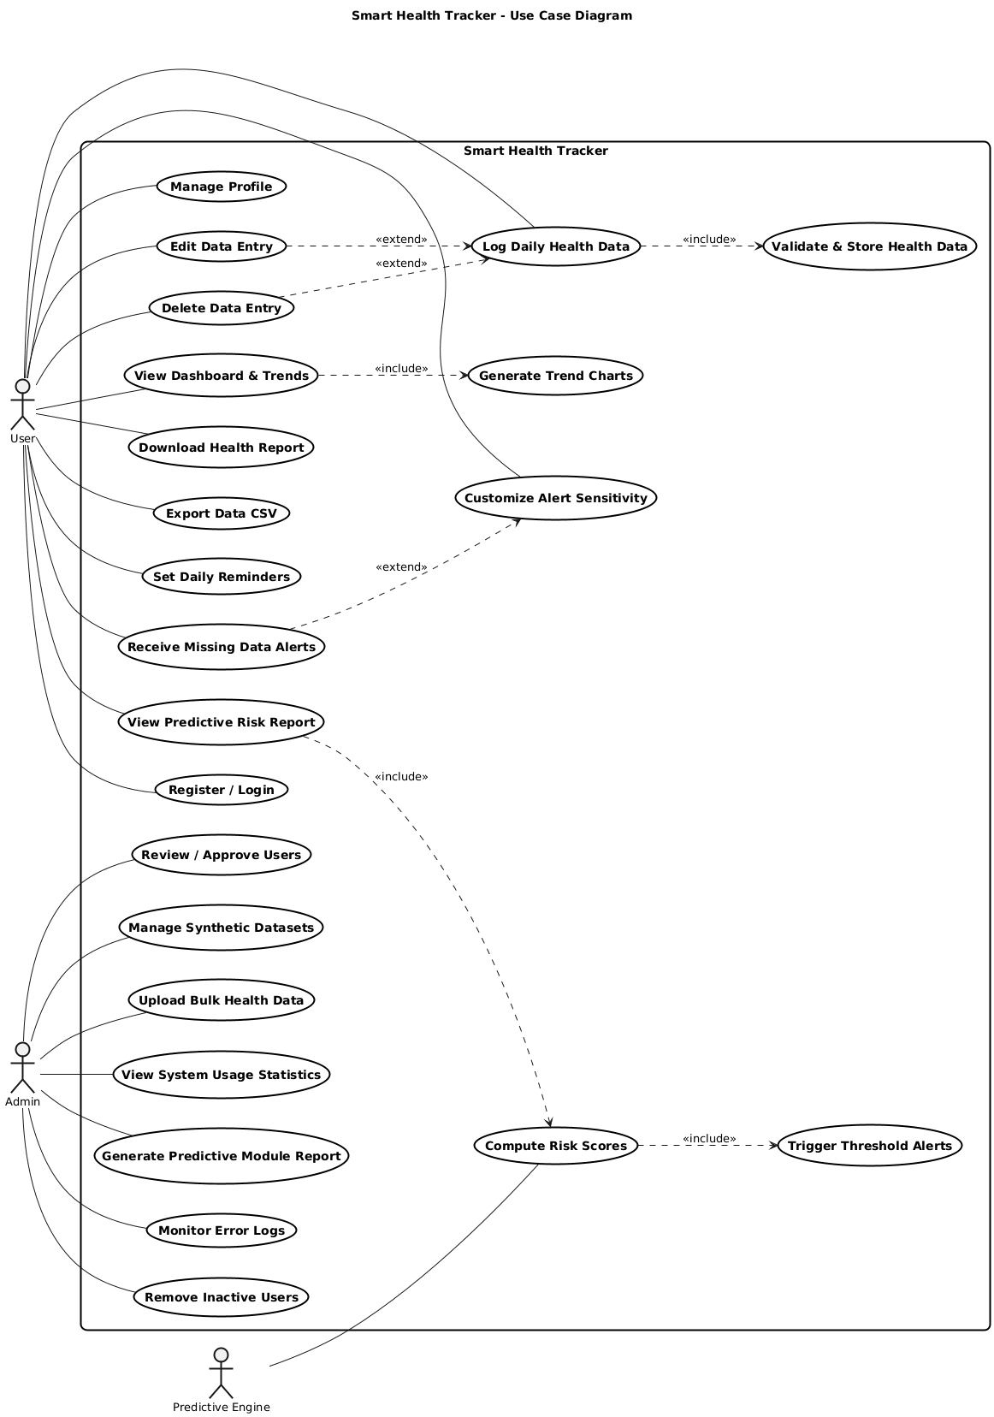
Figure.1 Use Case Diagram
The Figure.1 Use Case Diagram represents the functional interactions within the Smart Health Tracker system, illustrating how Users, Admins, and the Predictive Engine interact with the platform. The User performs essential functions such as registering, managing profiles, logging daily health data, and viewing dashboards that include visual trend charts and predictive risk reports. Users can also download or export reports, customize alert sensitivity, and receive notifications for missing data. The Admin oversees system-level operations, including managing synthetic datasets, monitoring errors, generating predictive module reports, and maintaining user accounts. The Predictive Engine automatically computes risk scores and triggers threshold-based alerts through included use cases like Compute Risk Scores and Trigger Threshold Alerts. Relationships such as include and extend show dependency and optional behavior among processes. Overall, this model visually defines user interactions and system functions essential for efficient health tracking and predictive monitoring

4.2 Activity Diagram
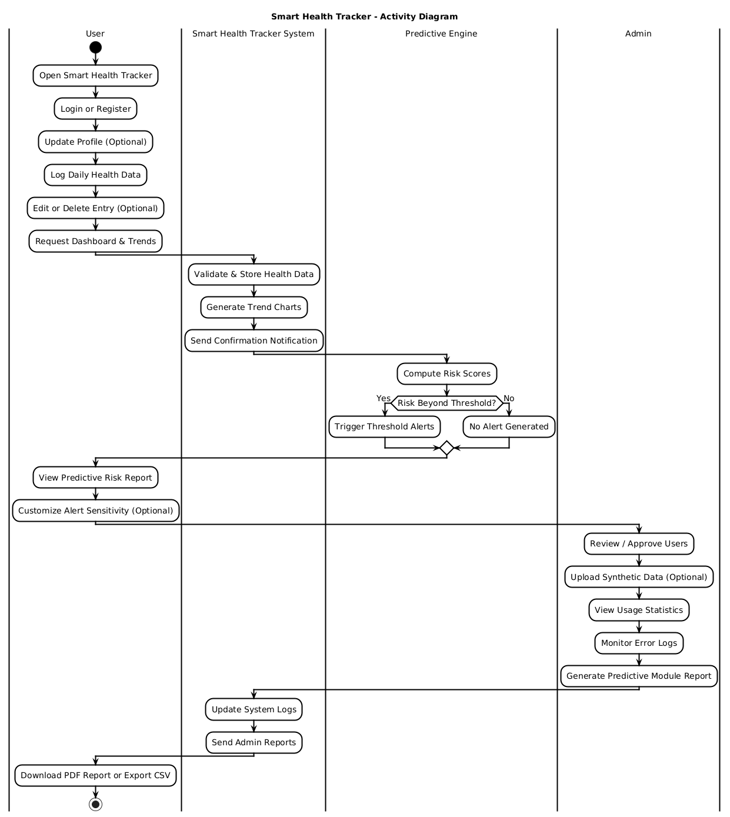
Figure.2 Activity Diagram
The Figure.2 Activity diagram shows the main flow of operations in the Smart Health Tracker system, describing how the user, the system, the predictive engine, and the admin interact. The process starts when a user opens the Smart Health Tracker, logs in or registers, and optionally updates their profile. The user then logs daily health data, which the system validates, stores, and converts into trend charts. After storing data, the predictive engine computes risk scores and checks whether the readings go beyond defined thresholds. If risks are detected, alerts are triggered; if not, the process continues normally. The user can then view predictive reports, adjust alert sensitivity, and download results as a PDF or CSV file. Meanwhile, the system updates logs and sends admin reports. The admin’s actions include approving users, uploading synthetic data, viewing system statistics, monitoring errors, and generating predictive module reports, completing the overall workflow of the tracker system.

4.3 Sequence Diagram
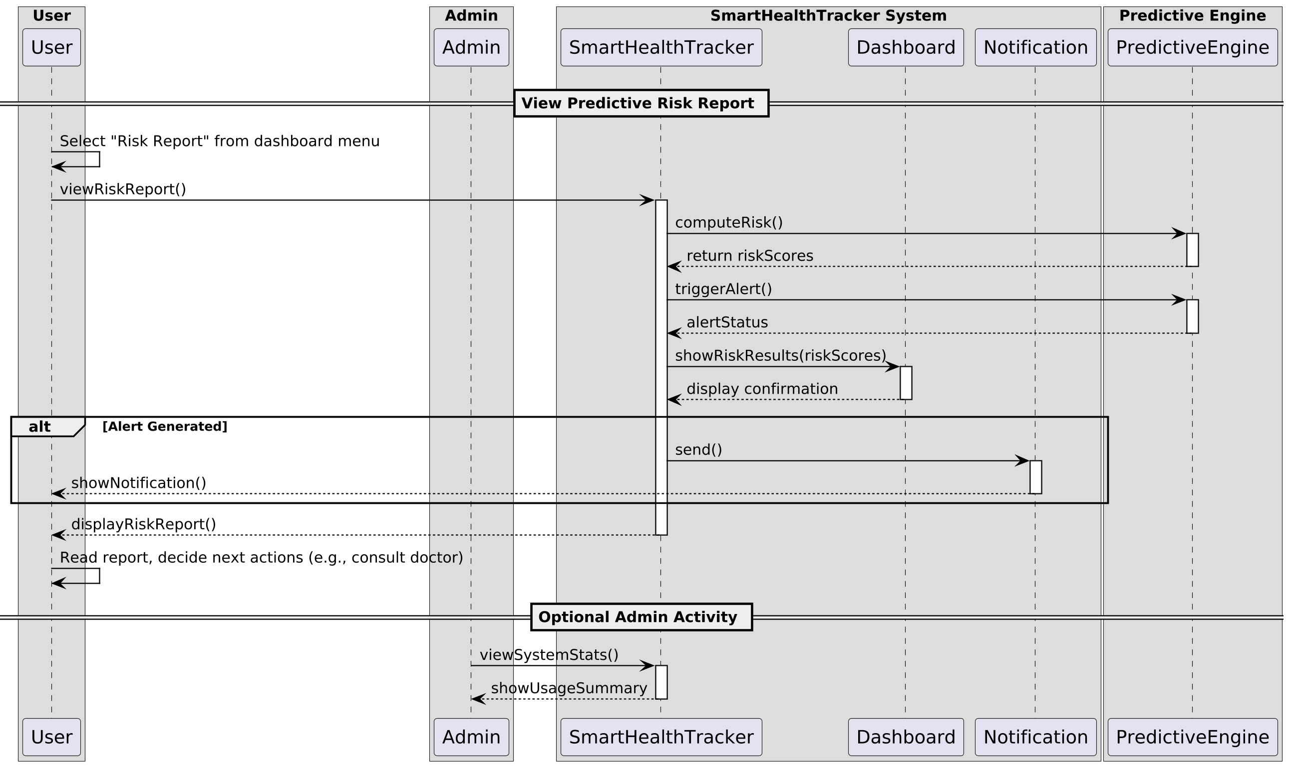
Figure.3 Sequence Diagram
The Figure.3 sequence diagram explains the process of viewing a predictive risk report in the Smart Health Tracker system. The interaction begins when the user selects the risk report option from the dashboard menu. The system communicates with the predictive engine to compute risk scores and check for any potential alerts. Once the analysis is complete, the system returns the computed scores and displays the results to the user. If the system detects that certain readings go beyond defined thresholds, it triggers an alert and sends a notification to the user. The user then views the detailed risk report and decides on the next steps, such as consulting a healthcare provider. Meanwhile, the admin can optionally review system statistics and generate summary reports to monitor system usage and performance. Overall, the diagram shows how data flows among the user, system, predictive engine, and admin to ensure accurate and timely health insights.

4.4 Class Diagram
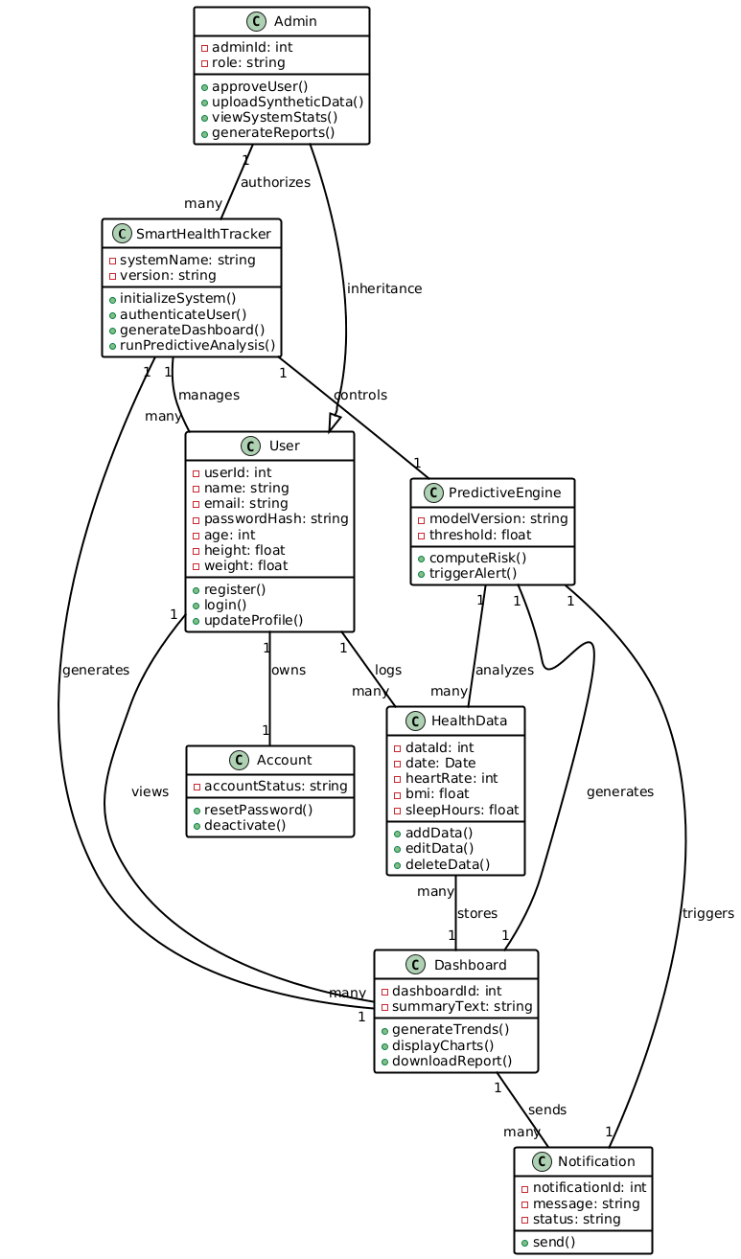
Figure.4 Class Diagram

The Figure.4 class diagram illustrates the structural design of the Smart Health Tracker system and its key components. The main class, SmartHealthTracker, manages the overall system and connects with other classes such as User, HealthData, PredictiveEngine, Dashboard, and Notification. The User class stores personal information and allows registration, login, and profile updates, while the Admin class inherits user properties and adds functions like approving users, uploading synthetic data, and generating reports. Each user manages an Account and logs multiple HealthData records that include heart rate, BMI, and sleep data. The PredictiveEngine analyzes stored health data to compute risk levels and trigger alerts when necessary. The Dashboard class generates and displays trend charts and downloadable reports, while the Notification class sends messages and alerts to users. The relationships between classes show one-to-many and many-to-many associations, defining how data flows and operations interact to support user health tracking and predictive analysis efficiently.

4.5 Object Diagram
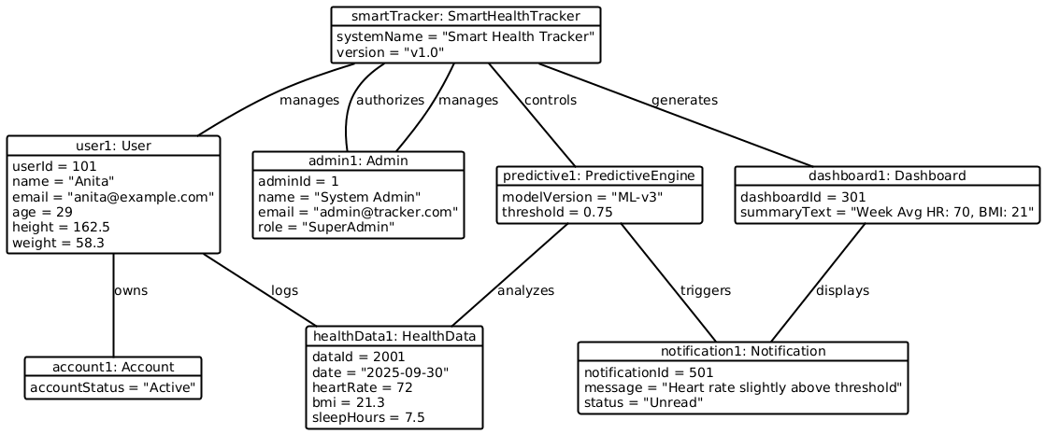
Figure.5 Object Diagram
Figure. 5 shows the object diagram of the Smart Health Tracker system, illustrating specific instances of the classes and their relationships during system execution. The central object, smartTracker: SmartHealthTracker, manages the system and connects to other objects such as user1: User, admin1: Admin, predictive1: PredictiveEngine, dashboard1: Dashboard, healthData1: HealthData, notification1: Notification, and account1: Account. In this instance, the user Anita (userId 101) owns an active account and logs her health data, including heart rate, BMI, and sleep hours. The predictive engine, version “ML-v3,” analyzes these values and detects that her heart rate slightly exceeds the defined threshold. Based on this analysis, the system generates a dashboard summary and sends a notification alert. The admin supervises overall operations and system authorization. This diagram captures a snapshot of how data and alerts flow between real system objects during health tracking and risk prediction.

5. Use case to class mapping table
Use Case No. & Name | Classes Required
1. Register / Login | User, Account, SmartHealthTracker
2. Manage Profile | User, Account, SmartHealthTracker
3. Log Daily Health Data | User, HealthData, SmartHealthTracker
4. Edit Data Entry | User, HealthData, SmartHealthTracker
5. Delete Data Entry | User, HealthData, SmartHealthTracker
6. View Dashboard & Trends | User, Dashboard, SmartHealthTracker
7. Download Health Report | User, Dashboard, SmartHealthTracker
8. Export Data CSV | User, Dashboard, SmartHealthTracker
9. Set Daily Reminders | User, Notification, SmartHealthTracker
10. Receive Missing Data Alerts | User, Notification, SmartHealthTracker
11. View Predictive Risk Report | User, PredictiveEngine, Dashboard, SmartHealthTracker
12. Customize Alert Sensitivity | User, PredictiveEngine, SmartHealthTracker
13. Review / Approve Users | Admin, User, SmartHealthTracker
14. Manage Synthetic Datasets | Admin, SmartHealthTracker
15. Upload Bulk Health Data | Admin, HealthData, SmartHealthTracker
16. View System Usage Statistics | Admin, SmartHealthTracker
17. Generate Predictive Module Report | Admin, PredictiveEngine, SmartHealthTracker
18. Monitor Error Logs | Admin, SmartHealthTracker
19. Remove Inactive Users | Admin, User, Account, SmartHealthTracker
20. Validate & Store Health Data | SmartHealthTracker, HealthData
21. Generate Trend Charts | SmartHealthTracker, Dashboard, HealthData
22. Compute Risk Scores | PredictiveEngine, HealthData, SmartHealthTracker
23. Trigger Threshold Alerts | PredictiveEngine, Notification, SmartHealthTracker

The traceability table links each functional use case to the structural classes that support it. This ensures that every requirement defined in the functional model is represented in the design. For example, use cases related to user actions such as Register, Manage Profile, and Log Health Data connect directly to the User, Account, and HealthData classes. Administrative use cases are supported by the Admin class working with SmartHealthTracker. System-driven use cases, including risk analysis and alerts, map to PredictiveEngine, Notification, and Dashboard. By mapping use cases to classes, the table verifies complete coverage and consistent design alignment.

6. Preliminary design and implementation ideas
The Smart Health Tracker will be built using Python as the main programming language. The backend will use the Flask framework to handle user login, save health data, run risk checks, and create alerts. The user interface will be made with HTML and CSS pages that are loaded through Flask to keep the design simple and easy to use. All user details and health records will be stored in a SQLite database for safe and quick access. The predictive part of the system will use Python logic to review past data, calculate averages, and find unusual patterns. If any reading crosses the set limits, the system will create an alert and show it on the dashboard. This design keeps the system clear, manageable, and within the allowed tools for this project.

7. References
Golinkin, W. (2025, June 19). APPs can improve population health and reduce costs – It’s time we set them free to do it. Forbes. https://www.forbes.com/sites/forbesbooksauthors/2025/06/19/apps-can-improve-population-health-and-reduce-costs--its-time-we-set-them-free-to-do-it/
Stewart, C. (2024, December 10). mHealth – Statistics and facts. Statista. https://www.statista.com/topics/2263/mhealth/

